Create a simple Mobile Website using jQuery Mobile
For this assignment we need to copy the CDN of JQuery Mobile.
- Create a new folder on any drive name it as JQuery
- Open this folder in VSCode editor.
- Right now there is nothing inside this folder.
- Create a file name it as index.html.
- Type here html and select html:5
- Now you will see the html boiler code.
- Change the title from Document to JQuery Mobile.
- If you open with live server you can see blank web page with title as JQuery Mobile.
- Next here we have to add JQuery Mobile CDN.
- For this go to Google then type JQuery Mobile CDN.
- Select the first result click on download then it will redirect to the webpage of https://jquerymobile.com/download/
- <link rel="stylesheet" href="https://code.jquery.com/mobile/1.4.5/jquery.mobile-1.4.5.min.css" />
- <script src="https://code.jquery.com/jquery-1.11.1.min.js"></script>
- <script src="https://code.jquery.com/mobile/1.4.5/jquery.mobile-1.4.5.min.js"></script>

Copy CDN three lines code inside the head section as below image.
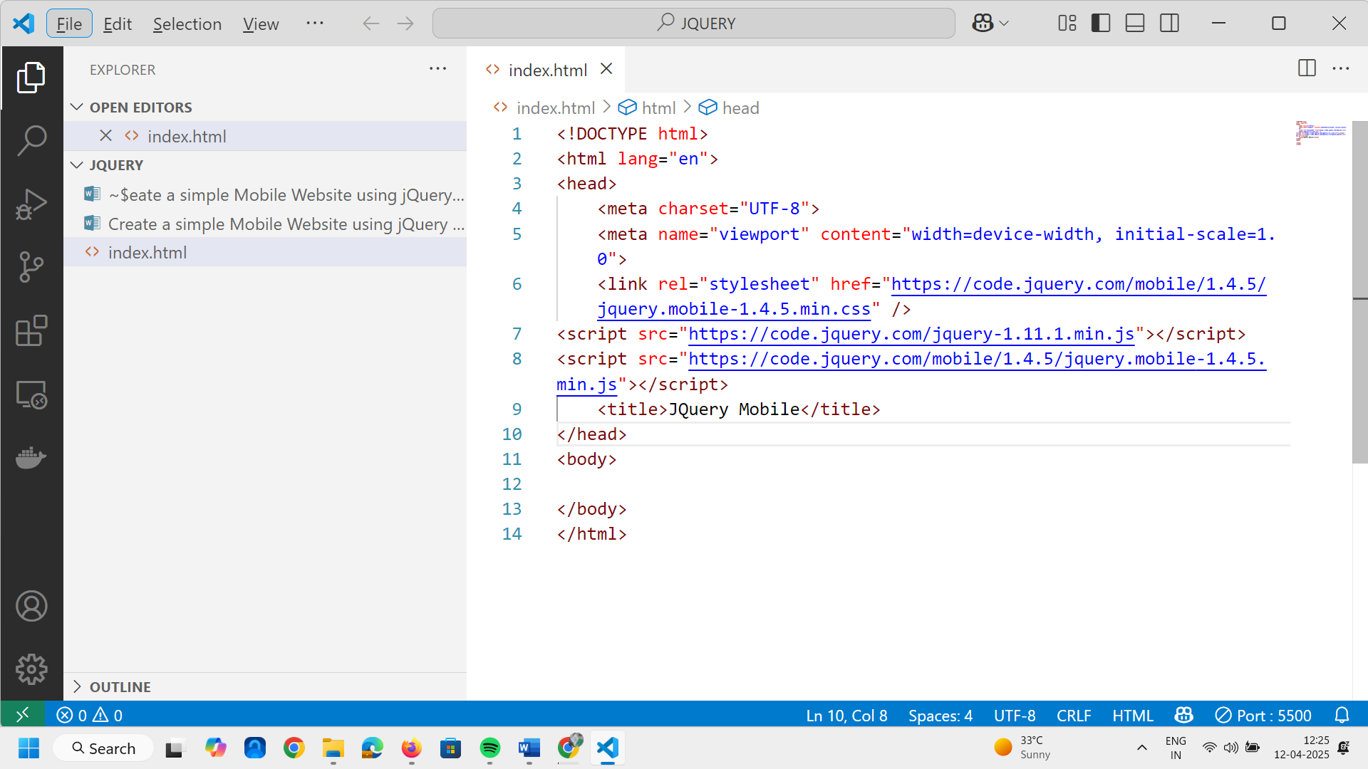

- Now go to the body part of html code Here we will create index.html . Press ctrl+? Key inside the vscode editor. This is will open comment line.
- Create one div and inside the div type this line data-role="page" id="home" considering this as home page.
- Now next step is to create a header again take one div inside the div give data-role = header WE will try to create a web page like one in SAE kondhwa website.
- Now lets create a new div tag Here I am creating a dummy website reflecting your college website. WE will create a list of anchor list as Home Department Contact and About.
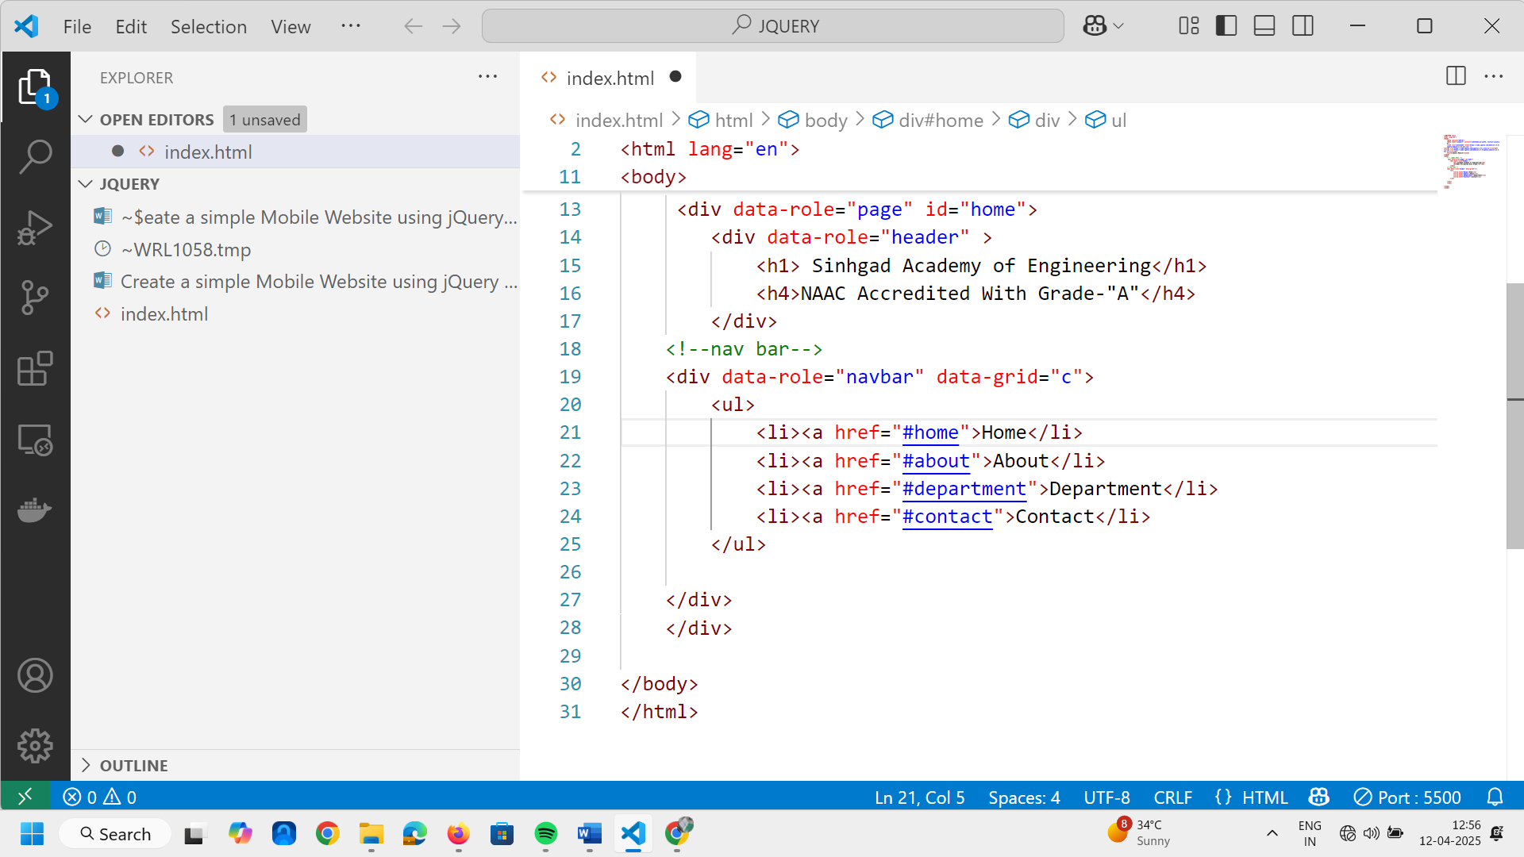

- Next thing is that we will provide the actual content before that we will write footer as.
WE consider data role as footer Here we will add Quick access using he tag and simple anchor tag for each and every page as below . <div data-role="footer" >
<h3>Quick Access</h3>
<a href="">Home</a><br>
<a href="">About</a><br>
<a href="">Department</a><br>
<a href="">Contact</a><br>
</div>
Here id’s needs to be same as above #home #about 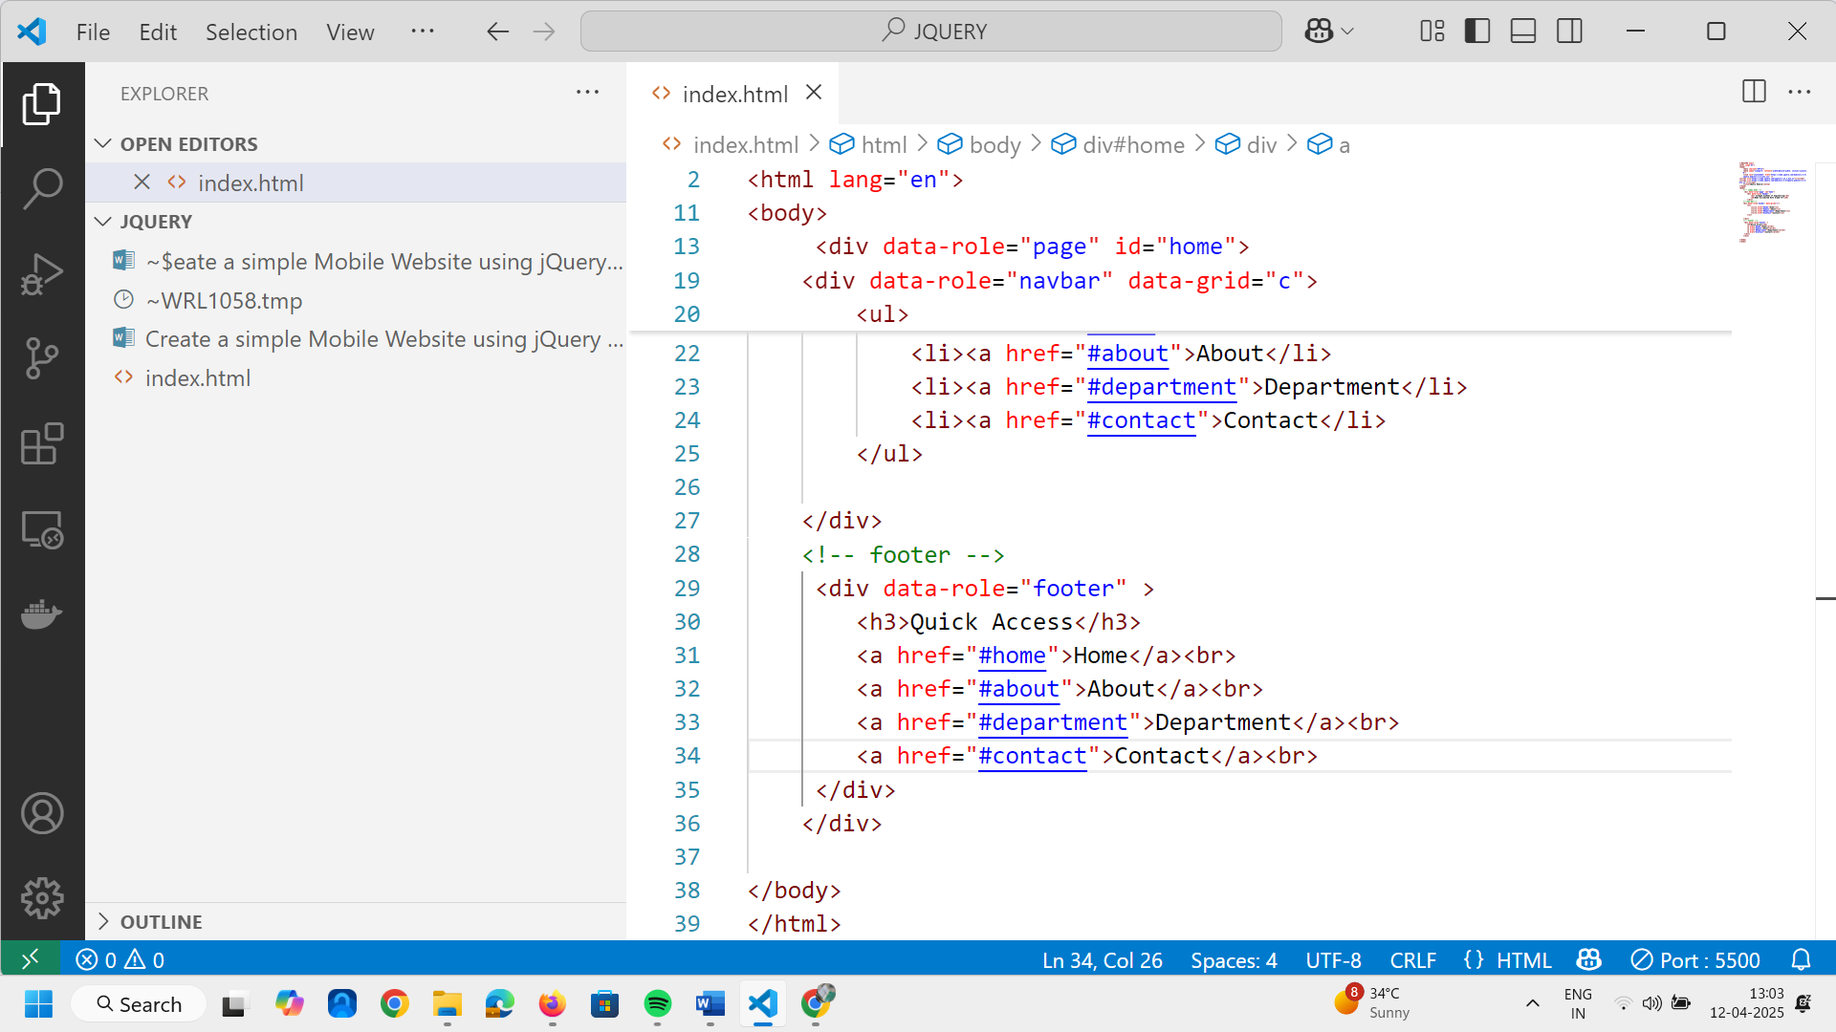

17.Copy all the footer inside the center tag

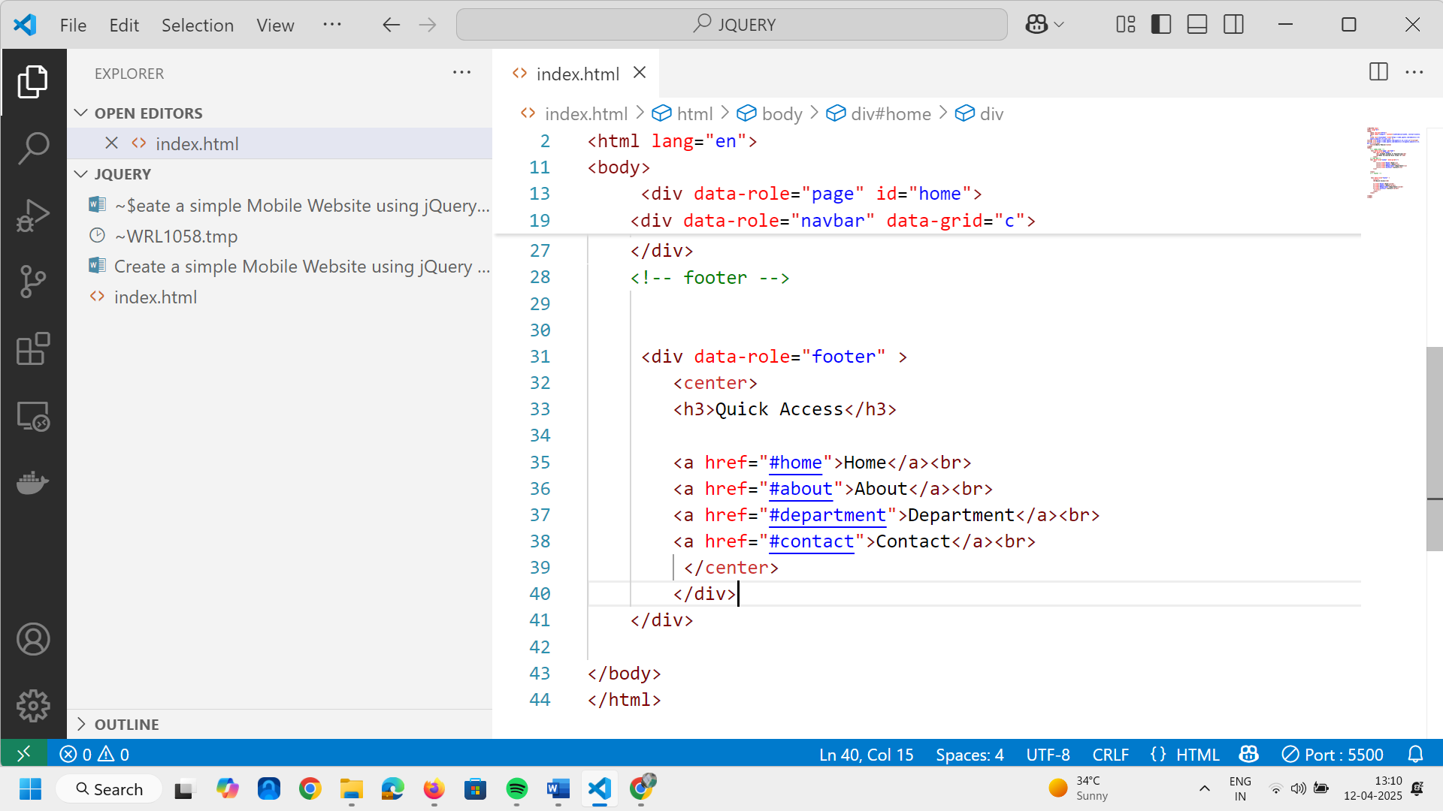
Output looks like this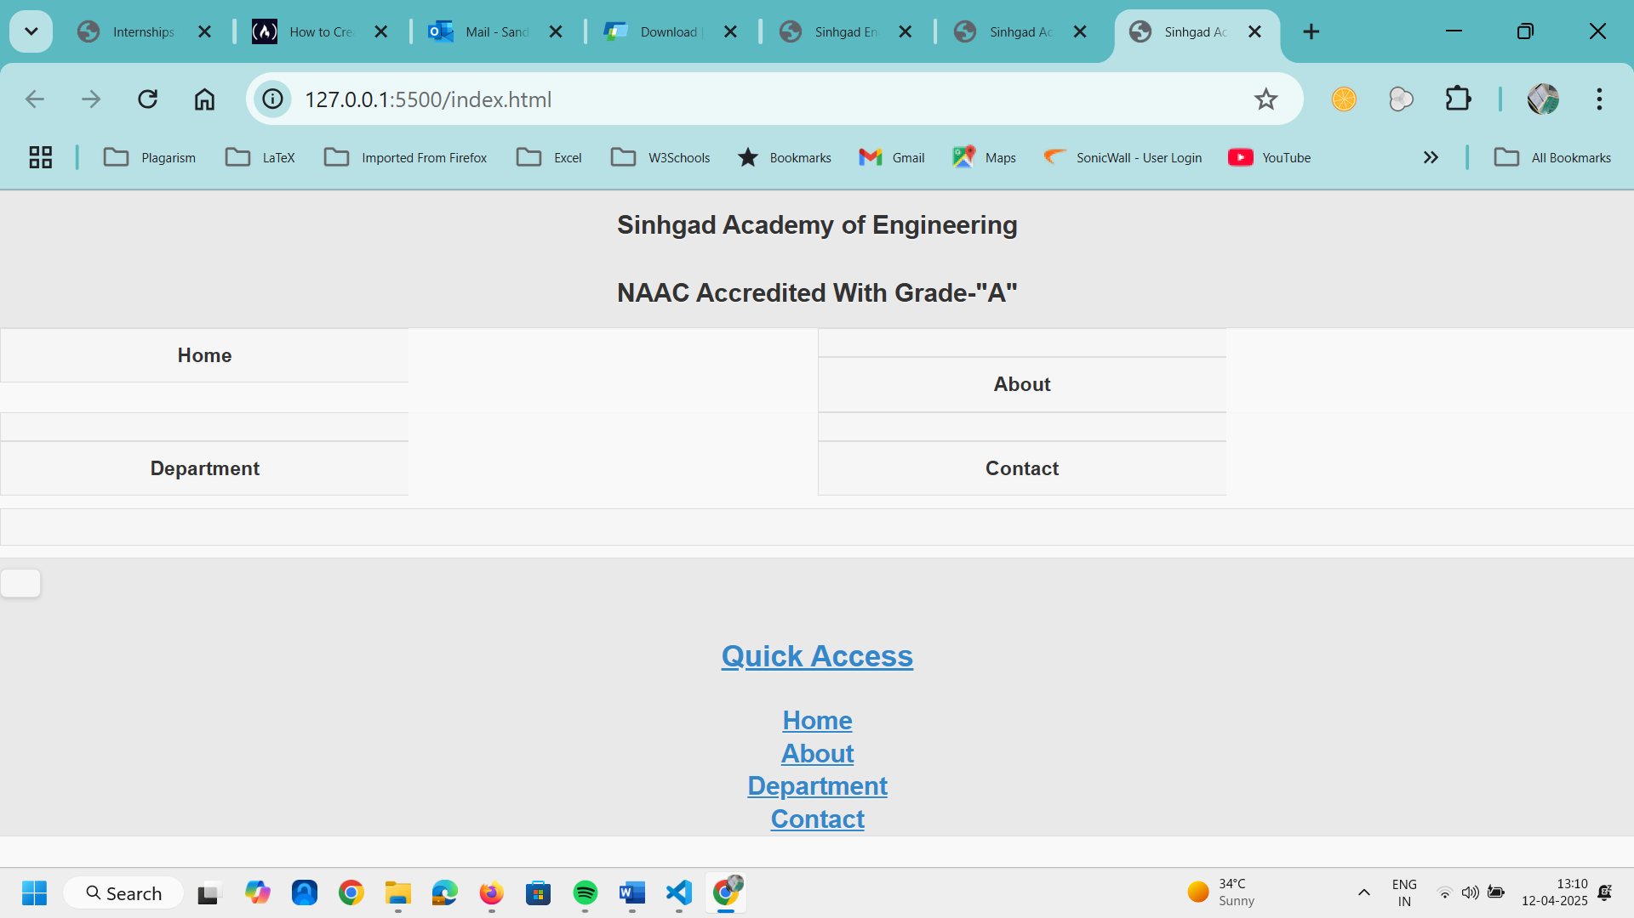

- Now we will add the actual contents above the footer. Data-role is content. take h3 tag
We will add some data inside the p tag. Here we require some justification so use inline css.
- After this we need to add vision and mission. For Vision we will add new div after content under that h3 tag for vision as below . We will add mission and vision in p tag. Text inside the vision and mission div we need to justify the content. 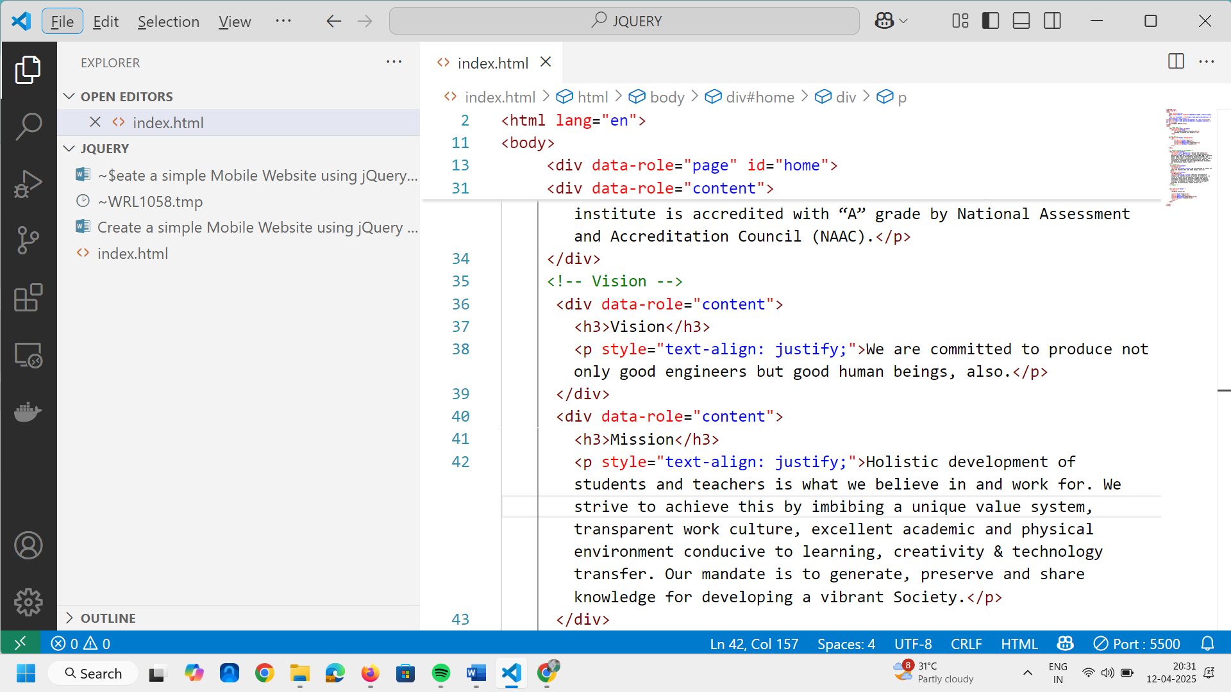
- Lets make the color of vision and mission green as welcome to SAE is color.

- Now next step is to create About Page if you are working on html you have to ceate about.html page to switch to the about page but now in jquery there is no need to create about.html page.

- Just copy all the contents of first page index.html we have to change the contents and footer is as it is. Inside this content we have to add some images inside this content.

- Next page to design is About Page.
- Open a New File for About About.html Copy all the content of first page

<!DOCTYPE html>
<html lang="en">
<head>
<meta charset="UTF-8">
<meta http-equiv="X-UA-Compatible" content="IE=edge">
<meta name="viewport" content="width=device-width, initial-scale=1.0">
<link rel="stylesheet" href="https://code.jquery.com/mobile/1.4.5/jquery.mobile-1.4.5.min.css" />
<link rel="stylesheet" href="style.css">
<script src="https://code.jquery.com/jquery-1.11.1.min.js"></script>
<script src="https://code.jquery.com/mobile/1.4.5/jquery.mobile-1.4.5.min.js"></script>
<title>SAE Kondhwa</title>
</head>
<body>
<!-- index.html -->
<div data-role="page" id="home">
<div style="background-color: green;" data-role="header" class="heading">
<h1 style="color:white; font-size: 18px;text-align: left;">SINHGAD ACADEMY OF ENGINEERING (SAE)</h1>
<h4 style="color: white; font-size: 12px; letter-spacing: 1px; ">AWARDED<br>
Center of Excellence for Best institution in Pune <br>
NAAC Accredited With Grade-"A", Pune,<br></h4>

</div>
<div data-role="navbar" data-grid="c">

<ul>
<li><a href="#home" class="ui-btn-active">Home</a></li>
<li><a href="#about">About</a></li>
<li><a href="#dept">Department</a></li>
<li><a href="#contact">Contact</a></li>

</ul>

</div><!-- /navbar -->
<div data-role="content">
<center>
<h3 style="color: green;"><u> SINHGAD ACADEMY OF ENGINEERING</u></h3>
<p style="text-align: justify;">Sinhgad Academy of Engineering (SAEE), Kondhwa </p>
</center>

<div>
<h3 style="color: green;">VISION</h3>
<p>We are committed to produce not only good engineers but good human beings, also..</p>
</div>
<div>
<h3 style="color: green;">MISSION</h3>
<p style="text-align:justify;">Holistic development of students and teachers is what we believe in and work for. We strive to achieve this by imbibing a unique value system, transparent work culture, excellent academic and physical environment conducive to learning, creativity & technology transfer. Our mandate is to generate, preserve and share knowledge for developing a vibrant Society.
</p>
</div>
<div>
<center>
<h3 style="color: green;">About Institute</h3>
<img src="5.jpg" height="250px" width="40%">
<p style="text-align:justify;">Teaching and Learning got a far deeper meaning when the Sinhgad Institutes were set up in August 1993. <br>

Honorable Prof. M. N. Navale, a great visionary and dynamic leader, laid the foundation of a Sinhgad Technical Education Society (STES). The Society is rightly imparting high standard of education at different institutes in the field of Engineering, Medical, Management, Pharmacy, Architecture, Computer Application, Education, Arts, Science, and Commerce and has acquired fame in a very short span.<br>

STES have received a great impact by winning the respect and admiration from many stake holders like students, parents, industrialists as well as other institutes in a span of just few years. Today, it has 12 sprawling, aesthetically landscaped and environment friendly campuses in and around Pune.<br>

STES’s Sinhgad Academy of Engineering (SAE) was established in year 2005. SAE is approved by All India Council for Technical Education (AICTE), New Delhi, Directorate of Technical Education (DTE), Mumbai, and is affiliated to Savitribai Phule Pune University, Pune. The institute is accredited with “A” grade by National Assessment and Accreditation Council (NAAC).<br>

The institute offers bachelor degree (B.E) in Computer Engineering, Information Technology, Electronics and Telecommunication Engineering, Mechanical Engineering and Civil Engineering with the total intake of 600. It also offers Masters Degree (M.E) in Electronics & Telecommunication Engineering (VLSI & Embedded Systems). Savitribai Phule Pune University (SPPU) has approved PhD research center in the department of Electronics & Telecommunication Engineering.
</p>
</center>
</div>
</div>

<div data-role="footer">
<h3>Quick Access</h3>
<center>
<a href="#home">Home</a> <br>
<a href="#about">About</a> <br>
<a href="#dept">Departments</a> <br>
<a href="#contact">Contact Us</a> <br>
<h6>All Rights are Reserved with SAE Kondhwa, Pune @2024-25</h6>
</center>

</div>

</div>
<!-- About.html -->
<div data-role="page" id="about">

<div style="background-color: green;" data-role="header" class="heading">
<h1 style="color:white; font-size: 18px;text-align: left;">SINHGAD ACADEMY OF ENGINEERING
</h1>
<h4 style="color: white; font-size: 12px; letter-spacing: 1px; ">Approved by AICTE, Permanently Affiliated
to SPPU, Pune,<br>
STES’s Sinhgad Academy of Engineering (SAE) was established in year 2005. SAE is approved by All India Council for Technical Education (AICTE), New Delhi, Directorate of Technical Education (DTE), Mumbai, and is affiliated to Savitribai Phule Pune University, Pune. The institute is accredited with “A” grade by National Assessment and Accreditation Council (NAAC). <br>
'Best College Award' by SPPU, Pune for academic year </h4>

</div>
<div data-role="navbar" data-grid="c">

<ul>
<li><a href="#home" class="ui-btn-active">Home</a></li>
<li><a href="#about">About</a></li>
<li><a href="#dept">Department</a></li>
<li><a href="#contact">Contact</a></li>

</ul>

</div>
<center>
<div class="row">
<img src="1.jpg" height="250px" width="40%">
<img src="2.jpg" height="250px" width="40%">

</div>
<br>
<div class="row">
<img src="3.jpg" height="250px" width="40%">
<img src="4.jpg" height="250px" width="40%">

</div>

</center>

<div data-role="footer">
<h3>Quick Access</h3>
<center>
<a href="#home">Home</a> <br>
<a href="#about">About</a> <br>
<a href="#dept">Departments</a> <br>
<a href="#contact">Contact Us</a> <br>
<h6>All Rights are Reserved with SAE Kondhwa, Pune @2024-25</h6>
</center>

</div>
</div>

<!-- Department.html -->

<div data-role="page" id="dept">

<div style="background-color: green;" data-role="header" class="heading">
<h1 style="color:white; font-size: 18px;text-align: left;">SINHGAD ACADEMY OF ENGINEERING, Kondhwa
</h1>
<h4 style="color: white; font-size: 12px; letter-spacing: 1px; ">Approved by AICTE, Permanently Affiliated
to SPPU, Pune,<br>
4th Time NBA Accredited, NAAC 'A+' Grade, ISO 9001:2015 Certified <br>
'Best College Award' by SPPU, Pune </h4>

</div>
<div data-role="navbar" data-grid="c">

<ul>
<li><a href="#home" class="ui-btn-active">Home</a></li>
<li><a href="#about">About</a></li>
<li><a href="#dept">Department</a></li>
<li><a href="#contact">Contact</a></li>

</ul>

</div>

<div data-role="content">
<ul data-role="listview">
<li><a href="#">Computer</a></li>
<li><a href="#">Civil</a></li>
<li><a href="#">Electronics and Telecommunication</a></li>
<li><a href="#">Electronics and Computer</a></li>
<li><a href="#">Electrical</a></li>
<li><a href="#">Information Technology</a></li>
<li><a href="#">Mechanical</a></li>
</ul>
</div>

<div data-role="footer">
<h3>Quick Access</h3>
<center>
<a href="#home">Home</a> <br>
<a href="#about">About</a> <br>
<a href="#dept">Departments</a> <br>
<a href="#contact">Contact Us</a> <br>
<h6>All Rights are Reserved with SAE Kondhwa, Pune @2024-25</h6>
</center>

</div>
</div>

<!-- contact.html -->

<div data-role="page" id="contact">

<div style="background-color: green;" data-role="header" class="heading">
<h1 style="color:white; font-size: 18px;text-align: left;">SINHGAD ACADEMY OF ENGINEERING, SANGAMNER
</h1>
<h4 style="color: white; font-size: 12px; letter-spacing: 1px; ">Approved by AICTE, Permanently Affiliated
to SPPU, Pune,<br>
</h4>

</div>

<div data-role="navbar" data-grid="c">

<ul>
<li><a href="#home" class="ui-btn-active">Home</a></li>
<li><a href="#about">About</a></li>
<li><a href="#dept">Department</a></li>
<li><a href="#contact">Contact</a></li>

</ul>

</div>

<div data-role="content">
<form action="">
<h3>Registration Form</h3> <br>
<label for="text-basic">Name</label>
<input type="text" name="text-basic" id="text-basic" value="">

<label for="text-basic">Email</label>
<input type="email" name="text-basic" id="text-basic" value="">

<label for="text-basic">Mobile</label>
<input type="text" name="text-basic" id="text-basic" value="">

<label for="text-basic">Password</label>
<input type="password" name="text-basic" id="text-basic" value="">

<label for="text-basic">Address</label>
<input type="text" name="text-basic" id="text-basic" value="">

<button class="ui-btn-active">Submit</button>
</form>

</div>

<div data-role="footer">
<h3>Quick Access</h3>
<center>
<a href="#home">Home</a> <br>
<a href="#about">About</a> <br>
<a href="#dept">Departments</a> <br>
<a href="#contact">Contact Us</a> <br>
<h6>All Rights are Reserved with SAE Kondhwa, Pune @2024-25</h6>
</center>

</div>
</div>

</body>

</html>

